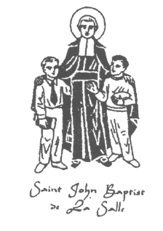
De La Salle 1910-1971
De La Salle Alumni Association
Annual Banquet - April 10, 2026
ARGOSY CASINO - 777 NW Argosy Pkwy, Riverside, MO 64150
Cocktail hour 11:30 a.m. – 12:30 p.m. (cash bar) – Lunch 12:30 p.m.
Your prepaid reservation must be mailed by March 25, 2026 so that we receive it in time to provide a count to Argosy. If you do not have a prepaid reservation you may not be able to sit with your class. A name card will be placed at each seat for those that prepaid their reservation. I will be posting on Face Book and in the monthly newsletter the reservations that have been received.
Prepaid $50.00 each – At the door $70.00 each
MEMORIAL MASS - 11:00 a.m. – April 9, 2026
St. John Francis Regis Church - 8941 James A Reed Rd, Kansas City, MO 64138
Questions? Contact cseigler@sbcglobal.net
We wish to have each class sit together, so early reservations are very important. If you are a walk-in please see Chris Seigler ’67, Treasurer for seating.
EVERYONE SHOULD BE SEATED BY 12:30 PLEASE
BANQUET RESERVATION – PLEASE MAIL YOUR RESERVATION EARLY
Mail to: De La Salle Alumni Association - PO Box 380083, Kansas City, MO 64138
Enclosed is my check for _________ banquet reservation(s) at $50.00 each $______________________
Name(s):______________________________________________________________ Class: ___________
Address:_____________________________________________ Phone:____________________________
Email address if you would like our monthly newsletter:________________________________________
Number attending the Memorial Mass _____ List any deceased alumnus, relative, friend to be
Remembered at the Mass _________________________________________________________________
Some alumni wish to attend but cannot drive: ______ Need a ride _____ Give a ride
I wish to include $__________ as a donation to the De La Salle Alumni Association a 501(c)(3).
All donations help further the works and mission of the Christian Brothers of De La Salle.

